Mathematics



|  |  |
| --- | --- |
| Counting and comparing | Can you gather two groups of toys/objects and compare which one has the most and least. Check by counting them. You might want to work out the difference. |
| Shopping | Can you go to the shop with and use the right coins to pay for a healthy snack? |
| Making patterns | Can you make or spot number patterns in the environment around you? E.g. odd and even house numbers. |

Topic



|  |  |
| --- | --- |
| Healthy eating | Can you write a food diary for a whole day? Writing down everything that you put into your brilliant body, including drinks. |
| Printing with food. | Can you pick different fruit and vegetables to print to create a master piece? |
| Seed hunt | Can you become seed detectives and locate the seeds in different fruits? Do they all look the same? |

Home Learning Challenges

Summer 2



Phonics

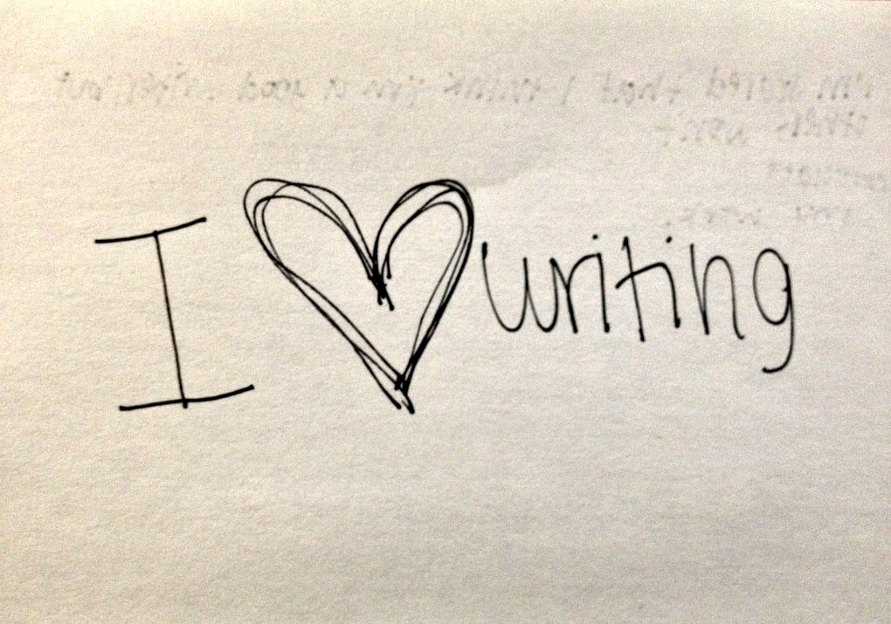

|  |  |
| --- | --- |
| Note book | Can make or get a special writing notebook to write silly sentences that will make us giggle. E.g. The dog put on a pink dress. |
| List writing | Can you write a list of your favourite foods, using bullet points? |
| Alphabet matching | Can you correctly match the capital and lower case letters from the alphabet? |

Literacy

|  |  |
| --- | --- |
| Letter writing | Can you write a letter to your teacher and tell them one of your proudest moments? |
| Poster | Can you create a poster about ‘Kind hands, Kind feet and Kind words’ to show the new children what we do in school. |
| Reading | Are you a proud reader, can you pick a book and share it with an adult? We would love to see a video on Tapestry of your proud reading. |

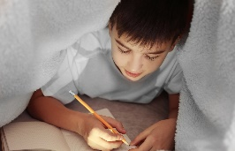

Important Note:

As we near the end of the children’s first year at school, it is import to reflect and celebrate their achievement whilst looking forward to Year 1.

In order to prepare the children fully and to give them the best possible start, it is vital to support daily home reading, writing and number/shape recognition.

We can see that the home learning completed, has a huge impact on embedding learning and building your child’s confidence, vital skills for Year 1 and beyond.

Physical Development

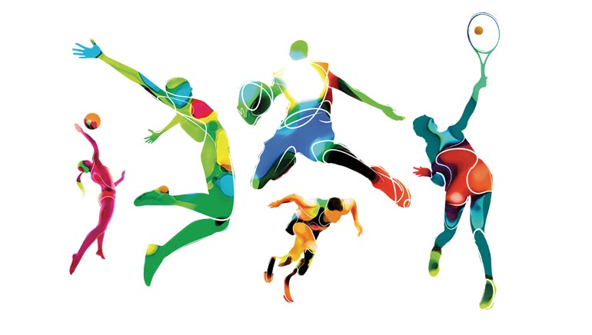

|  |  |
| --- | --- |
| Fine Motor | With an adult using a butter knife, can you chop different fruit to make your own yummy fruit salad? Takes photos for Tapestry. |
| Gross Motor | With your family can you use your sporting skills to create a new game? What are the rules in your game? |