**Spellings**

|  |  |
| --- | --- |
| **WB: 09.07.18** | **WB: 16.07.18** |
| **Preferred** | **Through** |
| **Beginner** | **Thought** |
| **Wrapped** | **Earth** |
| **Shrugging** | **Height** |
| **Hugging** | **Weight** |
| **Bitter** | **Appear** |
| **Difficult** | **Believe** |
| **Happen** | **Receive** |
| **Brilliant** | **Retrieve** |

Reading

Please read aloud to a grown up for 10 minutes, four times a week.

Remember to keep your Reading Record beautifully neat and up to date.

My Maths

Please log in to your My Maths account to complete your homework set. Remember to use the username: tintagel and the password : mymaths2014 before you enter your unique pass codes.

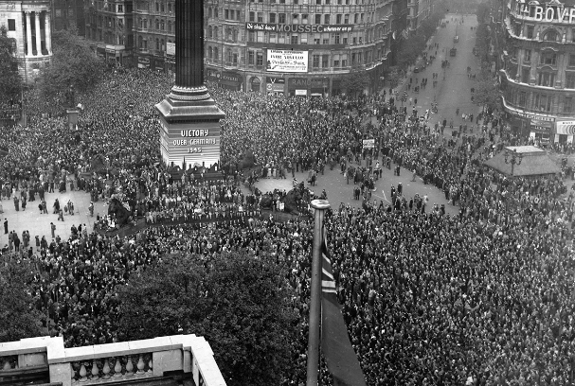

**Enquiry Homework – Due Thursday 19th July**

**Research which countries around the world were involved in WW2 and which side of the war they were on, the Allies or the Axis Powers. You can choose to present this any way you choose, such as on a map, groups of flags or any other way you can think of.**

**Please let me know if you need any support or resources to be able to complete the tasks.**

**We will review your home learning together in class, on Thursday 19th July.**

Literacy

Using your learning about life in Britain during the Second World War, write a poem or a diary to share a person’s feelings about the ending of the war. You could write from the perspective of a child, an evacuee or a soldier.

You can write any type of poem you like using plain or lined paper. You could also illustrate your poem or diary.

Remember poems do not have to rhyme.

**Class 3 Homework**

**09.07.18 due in 19.07.18**

Due in: Friday 15th June