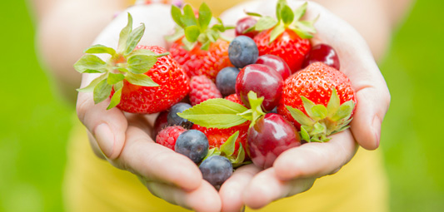

Physical Development

**Do I always have to win to be proud?**

Athletics

-Competition

-Sequencing skills

-Teamwork

-Sportsmanship

-Coordination

-Sports Day Practice

-Rules

-Challenge

-Encouragement

-Effort

-Pride

**Ball Handling**

-World Cup

-Multi-skills

Health and Self-care/Fitness

-Diet and hydration

-Eating well

-Beach safety

-SRE (sex, relationships education) *age appropriate*

-Growing up

Literacy

***How do fictional characters show pride?***

-Letter writing to new intake

-Non-fiction: healthy eating & beach safety posters.

-Fiction: The Very Hungry Caterpillar

-Creating our own stories

Communication and Language

***How do I feel about my learning journey so far?***

-Transition events

-Discussing healthy choices, understanding them and sharing information

-Reflecting on change together

-Self-reviews and Personal recounts

Personal, Social and Emotional Development

***Becoming a Year 1***

-The future

-Our dreams

-We can do it!

***What makes me proud?***

-Feeling confident

-Effort and resilience

-Being proud of others around me

Mathematics

***Can I try a different method?***

-Counting and comparing numbers

-Recognising patterns and relationships with number

-Shape and direction

-Time and money

-Number Sentences

-Taking risks and developing our mathematical thinking

Understanding the World

***How can I make a healthier world?***

-Knowing my body and what it can do

-Sport around the world

-How have sports changed over time?

-Beach safety

-Having a positive impact on the world around me

-Healthy food choices from trees and plants

-World events (World Cup)

Expressive Art and Design

***Can I adapt?***

-Sports Day Dance

-How do we share, change and adapt our ideas?

-Designing, making and adapting flags

-Cultural music

Notices

* TPS: Our EYFS multiskills event is on the 15th June
* Remember you will need you PE kit including trainers for lessons and the upcoming Sports Day on 4th July.
* Don’t forget the ‘fly-up days on the 2nd and 3rd of July.
* Healthy Living week is on the 2nd July.
* Due to the increasingly warm weather you might need to put on sun cream before school and bring in a hat. However, due to the changeable weather it is still important to bring a jumper/raincoat each day.
* We are hoping to organise a beach visit, more information will follow and will be dependent on transport and tide times.
* Our EYFS graduation will be held towards the end of term to celebrate all the children’s hard work. Look out for a letter shortly.

**EYFS Class: Summer 2**

**What does pride look like?**

**Our Value: Pride**