English

We have been reading Fables in English. We know the Fox and the Raven, The Hare and The Tortoise and The Boy Who Cried Wolf.

Can you find and discover another Fable to share with the class? Aesop wrote many Fables, do you have a favourite?

Perhaps you could write your own fable with an important message or moral at the end?

Maths

My Maths – New tasks have been set for you. Log on and have a go. Remember that you can access the online lesson if you need help.

Measure objects around your house. Can you find things to measure in cm, mm and m? Can you put them in order from smallest to largest?

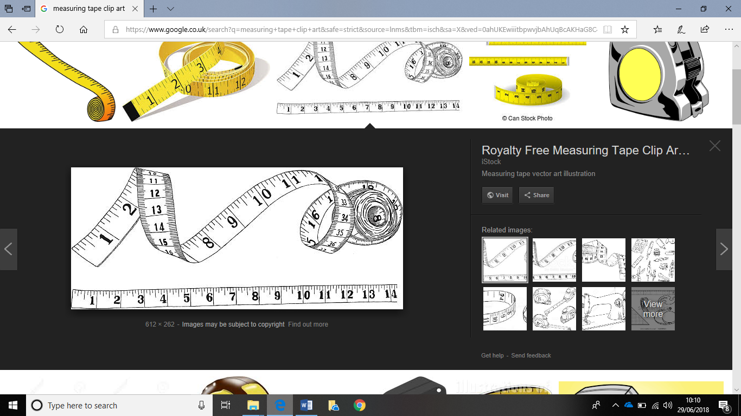

**How can we measure Pride?**

**Our Value is Pride**

Learning Log Class 2

Set: 09.07.18

Due in: 20.07.18

Enquiry Homework

Geography / History – Flags and facts! Choose a country from the British Isles. Find out its flag and other fascinating facts about that country such as if it has a national anthem, a national dish, flower or capital city. Can you make and present your findings in an interesting poster that we could display in the classroom?

